Title of the Report
- Author1
- Author2
- Author3
- Author4
- Author5
- Author6

Acknowledgements

Abstract

Glossary
Abbreviation | Description
EPS | European Project Semester
ISEP | Instituto Superior de Engenharia do Porto
USB | Universal Serial Bus

1. Introduction

1.1 Presentation
Present here the team

1.2 Motivation
Describe here your motivation for choosing this project

1.3 Problem
Provide here the problem you are tacking

1.4 Objectives

1.5 Requirements
Specify here the identified and mandatory requirements the solution has to fulfil

1.6 Tests

1.7 Report Structure
Chapter | Description
1 | …
2 | …
3 | …
4 | …
5 | …
6 | …
7 | …
8 | …

2. Background and Related Work
This chapter provides the reader with the relevant technical-scientific background as well as existing related products and research, also known as the state of the art, in the field(s) of the project.

2.1 Introduction
Provide here the structure of this chapter.

2.2 Concepts
Provide here all relevant concepts related to the topic(s) of the project

2.3 Products
Search, select and describe related commercial solutions

2.4 Projects
Search, select and describe related research projects

2.5 Comparative Analysis
Compare selected products and projects considering the requirements of your own solution

2.6 Summary
Provide here the conclusions of this chapter and make the bridge to the next chapter.
Based on this study of the state of the art, the team decided to adopt the following <specify here the architecture, technique(s), material(s), component(s)> because <specify here the technical/scientific reasons>.

3. Project Management
Provide here the structure of this chapter.

3.1 Scope
Document the boundaries of your project. Document the product scope (the extent of what your project will produce) and the project Scope (summary of the work needed to produce it).

3.2 Time
Document the key milestones of your project, mapping key phases to reference deadlines.

3.3 Cost
Document the planned vs. effective costs of your project.

3.4 Quality
Document quality metrics that will apply to your project deliverables, associated thresholds and how they should be reviewed.

3.5 People
Identify key people related to the project and associated roles.

3.6 Communications
Document how your team will manage communications, describing communication channels, meetings, etc.

3.7 Risk
Identify key risks (product and project level), evaluate them and define how they should be handled (responses) and monitored.

3.8 Procurement
Document your procurement management strategy including make vs buy decisions, materials/services to be acquired, sources, costs, timings, etc.

3.9 Stakeholders Management
Define how you will manage stakeholders to keep them engaged.

3.10 Project Plan
Define your optimal sprint duration and plan your sprints until project end using Global Sprint Plan Table .
Table 1: Global Sprint Plan
Sprint | Start | Finish
1 | Start date | End date
2 | Start date | End date
3 | Start date | End date
4 | Start date | End date
5 | Start date | End date
6 | Start date | End date
7 | Start date | End date

Build your project backlog, including all relevant tasks/deliverables, using Project Backlog Table . Prioritize all backlog items (PBI), keeping higher priority items at the top, and lower priority at the bottom.
Table 2: Project Backlog
PBI | Title | Status
Z | Sample task | To do
K | Sample task | To do
D | Sample task | To do
A | Sample task | To do
B | Sample task | To do
E | Sample task | To do
C | Sample task | To do

Plan each sprint at its beginning (Sprint Planning session) using the Sprint Plan Table .
Table 3: Sprint Plan
Sprint | Task | Duration (d) | Responsible | Involved
1 | Z | 2 | X and Y | X, Y, Z, W
2 | K | 3 | Z | X, Y, Z, W
3 | D | 1 | W, Y and Z | X, Y, Z, W
4 | A | 1 | Y | X, Y, Z, W
5 | B | 2 | Z and W | X, Y, Z, W
6 | E | 4 | X and W | X, Y, Z, W
7 | C | 2 | Y and Z | X, Y, Z, W

Review each sprint at its end and update each item status on the Progress Register Table .
Table 4: Project Progress Register
Sprint | PBI | Responsible | Involved | Status
1 | Z | X and Y | X, Y, Z, W | Done
2 | K | Z | X, Y, Z, W | Done
3 | D | W, Y and Z | X, Y, Z, W | Done
4 | A | Y | X, Y, Z, W | Done
5 | B | Z and W | X, Y, Z, W | In progress
6 | E | X and W | X, Y, Z, W | In progress
7 | C | Y and Z | X, Y, Z, W | In progress

Identify key project deliverables (when they will be started and completed) and build a release Gantt chart. See Figure for inspiration.
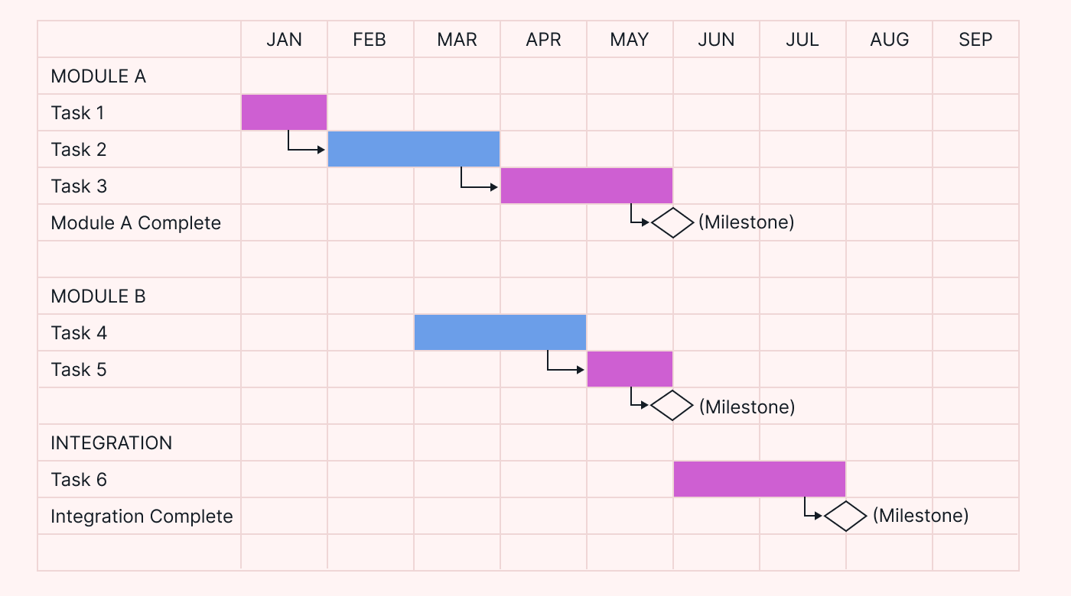
Figure 1: Release Gantt chart

3.11 Sprint Outcomes
Include the outcomes of all sprint reviews (what was the sprint backlog, completion status, planned capacity vs. achieved velocity).

3.12 Sprint Evaluations
Include the summary of all the sprint retrospectives, including any actions implemented as part of the team’s continuous improvement strategy.

3.13 Summary
Provide here the conclusions of this chapter and make the bridge to the next chapter.

4. Marketing Plan

4.1 Introduction
Provide here the structure of this chapter.

4.2 Business Idea Formulation

4.3 Business Model

4.4 Market Analysis

4.5 SWOT Analysis

4.6 Strategy

4.6.1 Strategic Objectives

4.6.2 Segmentation and Targeting

4.6.3 Positioning

4.6.4 Marketing-Mix

4.6.5 Brand

4.7 Marketing Programmmes

4.7.1 Programmes

4.7.2 Budget

4.7.3 Control

4.8 Summary
Provide here the conclusions of this chapter and make the bridge to the next chapter.
Based on this market/economic analysis, the team decided to create <specify the type of product> intended for <specify the market niche> because <specify here the relevant market-related reasons>. Consequently, the team decided to design a solution with the following <specify here the features added for market reasons>.

5. Eco-efficiency Measures for Sustainability
Sustainability is a widely used concept that is applied by companies, organizations and politicians in various contexts. This chapter deals with specific measures to minimize the environmental footprint. An overview of the most important aspects of sustainable development and eco-efficiency. The eco-efficiency measures for sustainability provide a foundation for understanding our environmental responsibility and resource efficiency.

5.1 Introduction
Throughout history, geo-resources have served as crucial elements in providing all kinds of raw materials. However, excessive consumption has inflicted significant damage on the ecosystems, resulting in pollution and resource depletion. Sustainable engineering presents itself as a solution to this pressing issue, aiming to reconcile the demands of environmental preservation with economic growth. Sustainable engineering plays a fundamental role in these processes as it is rooted in the three pillars of sustainable: environment, society, and the economy. In simple terms, sustainability means to satisfy existing needs, without eliminating the needs of future generations. This correlates also with the 17 sustainable development goals (SDGs) from the United Nations. By adapting to nature, rather than trying to control it, more sustainable practices and products can be created.

5.2 Environmental
The environmental influence of products is of high importance in many aspects such as by depleting natural resources or emitting greenhouse gases. Concerning the product, it is important to try to reduce negative influences on the environment. This is achieved by reducing, reusing and recycling raw materials; taking into consideration the energy consumption in all phases of the project, as well as by minimizing transport.

5.3 Economical
The economic aspect of sustainability relates to the efficient and cost-effective utilization of resources, aiming to minimize environmental impact while ensuring long-term economic viability. The goal is to strike a balance between environmental responsibility and financial success by devising products, processes, and business models that are both ecologically and economically advantageous. Thus, the sustainable economy focuses on the responsible management of economic, social, and environmental resources to support the well-being of current and future generations. The goal of economic sustainability is to achieve economic growth without making the negative environmental trade-offs that traditionally occur. It also means that the price of the product matches the time the product fulfils its purpose.

5.4 Social
Social sustainability is about identifying and managing business impacts, both positive and negative, on people. It refers to the ability of a project or initiative to foster positive and inclusive social interactions while considering the long-term effects on society. The social aspect of sustainability deals with the community, education, equality, justice, social resources, health, well-being, quality education and quality of life. The product should meet those social aspects.

5.5 Life Cycle Analysis
One crucial task is to assess how each stage of the life cycle contributes to the overall environmental impact. This analysis is typically aimed at prioritizing enhancements in products or processes and comparing various products for internal purposes. Life Cycle Analysis (LCA) is a method for evaluating the environmental impact of a service or product throughout its life cycle, from design to end-of-life management. LCA or life cycle assessment is an essential tool to support sustainable development decision-making, as well as to assess the potential environmental impacts of a product, material, process or activity.

5.6 Summary
Provide here the conclusions of this chapter and introduce the next chapter.
Based on this sustainability analysis, the team chose <specify here the design, technique(s) material(s), component(s)> for the following <specify here the relevant sustainability-related reasons>.
Consequently, the team decided to design a solution with the following <specify here the features added for sustainability reasons>.

6. Ethical and Deontological Concerns

6.1 Introduction
Provide here the structure of this chapter.

6.2 Engineering Ethics

6.3 Sales and Marketing Ethics

6.4 Environmental Ethics

6.5 Liability

6.6 Summary
Provide here the conclusions of this chapter and make the bridge to the next chapter.
Based on this ethical and deontological analysis, the team chose <specify here the design, technique(s) material(s), component(s)> for the following <specify here the relevant ethics-related reasons>.
Consequently, the team decided to design a solution with the following <specify here the features added for ethical reasons>.

7. Project Development

7.1 Introduction
Provide here the structure of this chapter.

7.2 Ideation

7.3 Concept

7.4 Design

7.4.1 Structure
Add and explain thoroughly the: (i) initial structural drafts; (ii) material selection; (iii) detailed drawings; (iv) 3D model with load and stress analysis; (v) colour palette.

7.4.2 Smart System

Hardware
Include and explain in detail the: (i) black box diagram; (ii) hardware component selection (use tables to compare the different options for each component; (iii) detailed schematics; (iv) power budget.

Software
Describe in detail the: (i) use cases or user stories for the smart device and app; (ii) selection of development platforms and software components (use tables to compare the different options); (iii) component diagram.

7.4.3 Packaging
Present and explain the: (i) initial packaging drafts; (ii) detailed drawings; (iii) 3D model with load and stress analysis, if applicable.

7.5 Prototype
Refer main changes in relation to the designed solution.

7.5.1 Structure
Detail and explain any changes made in relation to the designed solution, including structural downscaling, different materials, parts, etc.

7.5.2 Hardware
Detail and explain any change made in relation to the designed solution. In case there are changes regarding the hardware, present the detailed schematics of the prototype.

7.5.3 Software
Detail and explain any changes made in relation to the designed solution, including different software components, tools, platforms, etc.
The code developed for the prototype (smart device and apps) is described here using code flowcharts.

7.5.4 Tests & Results

Hardware tests
Perform the hardware tests specified in 1.6 Tests. These results are usually presented in the form of tables with two columns: Functionality and Test Result (Pass/Fail).

Software tests
Software tests comprise: (i) functional tests regarding the identified use cases / user stories; (ii) performance tests regarding exchanged data volume, load and runtime (these tests are usually repeated 10 times to determine the average and standard deviation results); (iii) usability tests according to the System Usability Scale.

7.6 Summary
Provide here the conclusions of this chapter and make the bridge to the next chapter.

8. Conclusions

8.1 Discussion
Provide here what was achieved (related with the initial objectives) and what is missing (related with the initial objectives) of the project.

8.2 Future Development
Provide here your recommendations for future work.

Bibliography
Will be added automatically by citing, in the body of the report, entries specified in BibTeX format and stored in the https://www.eps.dee.isep.ipp.pt/doku.php?id=refnotes:bib file
PS - If you have doubts on how to make citations, create captions, insert formulas, etc. visit this page with examples and select “Show pagesource” to see the source code.

